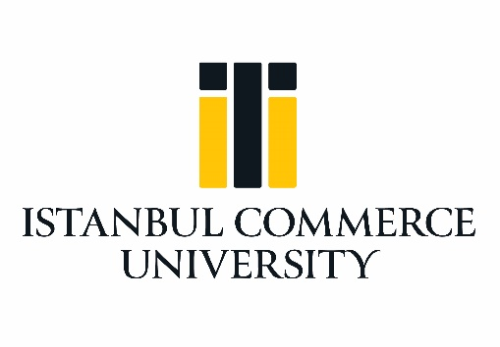

Erasmus+ Programme

Letter of Confirmation (SMP)
Academic Year 2019/2020

We hereby confirm that Mrs/Mr _____________________________________, from Istanbul Commerce Universtiy (TR ISTANBU10) carried out a period of study mobility at the _________________________________________ (name of the host institution), within the Erasmus+ Programme from ___/___/____ to ___/___/____.

Name and status (host institution): _________________________________________

Signature:

Stamp of Institution:

Date: _____/_____/______ (to be signed at the end of the training period).

Limpar Dados Thank You!

Istanbul Commerce University
Exchange Programs Coordinatorship
erasmus@ticaret.edu.tr

